Let's have fun with

Here's an easy recipe:
1 cup flour 1/4 cup salt
1 Tbs. cream of tartar (optional) 1 tsp. oil
1/2 cup warm water food coloring (optional)

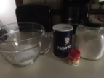
Directions:

mix all the dry ingredients in a bowl (Cream of tartar is a preservative, it just makes the dough last a bit longer. That's why you don't really need it.)
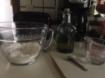
*if you're using food coloring, add it to the water now (I didn't have any at my house.)
add the water and oil
stir and knead!


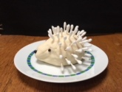
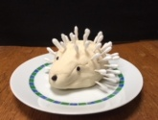
I cut cotton swabs in half and made a hedgehog. The eyes and nose are swabs too. I just colored them black with a sharpie.

What will you make??

