Let's make a
Parachute

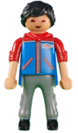

You will need:
    - a paper napkin (heavier dinner napkins work best; you can also cut a square from a plastic bag) ew! plastic, but at least you're recycling
    - tape
    - hole punch or scissors
    - yarn (string or skinny ribbon will work too)

    - a lego or playmobile guy Don't worry if you don't have one. I'll show you how to make a parachuter at the end.



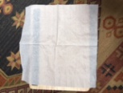
Let's begin:
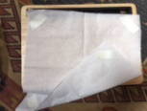
open the napkin fully
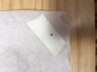
put a strip of tape at each corner - put the tape on both the front and back to add strength
make a hole at each corner on the tape
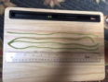
cut four pieces of yarn 12" long
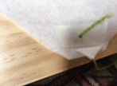
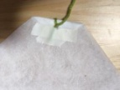

tie a piece of yarn through each hole and tape the ends
*see how I folded the corner up to the tape when I tied the knot?
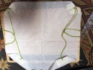
tie two pieces of the yarn on one side together - put the knot at about 4" from the napkin
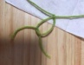
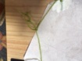
do the same with two pieces of yarn on the other side
make two more knots toward the ends of the yarn 1. 2.
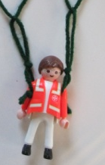
stick the arms of your guy through the hole between the two knots
find a high place and drop!

Here's how you can make a guy for your parachute:
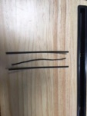
use 3 twist ties
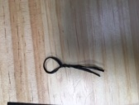
fold one in half, make "the head" and twist a body
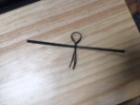
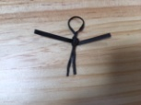
put the second tie just below the head and twist around until the arms are how you like them
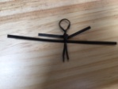
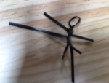
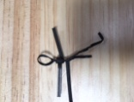
put the third tie just below the arms - twist only one side down the body and around one of the ends of the body piece
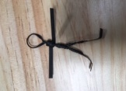
now do the other side and there you have a parachuter!

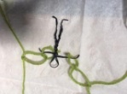
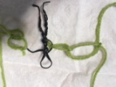
put the arms through the holes between the last two knots; for extra security, I wrap the arm back around the body



Gaahh! We're under attack!!

