Hi Crafters! Are you hanging in there? I sure do miss creating things with you! But in the meantime, here's another fun thing to do when you're in the mood...
Bird Finger Puppets

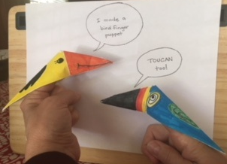

All you need is paper
scissors
crayons or markers

Ready?

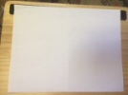
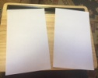
1. fold your paper in half and cut it into two
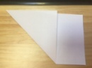
2. just use one half and fold it diagonally
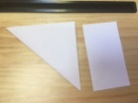
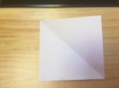
3. cut along the edge to make a square
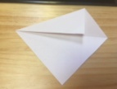
4. fold one side over to match the edge of the paper to the center fold
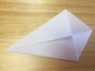
5. do it again on the other side - it will look like a kite

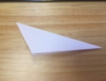
6. fold it in half
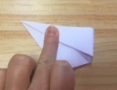
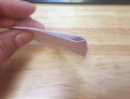
7. fold it matching two corners *but don't crease it!*
just pinch the top to mark the middle

8. now you're going to make a fold from that pinch middle mark to the bottom corner,
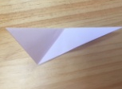
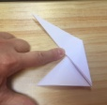
like this

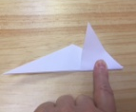
9. working with the triangle "hanging down" in the picture, fold it back up over the "long triangle"

10. keep folding it around the triangle so it wraps to the back of your puppet
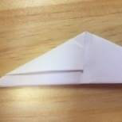
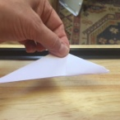
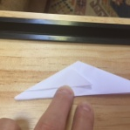
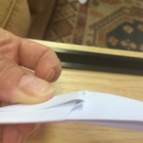

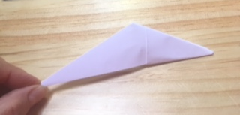
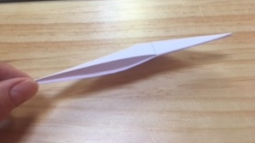
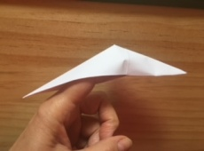
It should look like this...

11. and now the fun part! COLOR!

Be creative, have fun, make as many as you want.
Maybe put on a puppet show for your family!
Sing Two Little Dicky Birds to your little brother or sister...
Two little blackbirds sitting on a hill.
One named Jack and one named Jill.
Fly away Jack, fly away Jill.
Come back Jack, come back Jill.
Two little blackbirds sitting on some snow
One named Fast and one named Slow.
Fly away Fast, fly away Slow.
Come back Fast, come back Slow.
Two little blackbirds sitting on a cloud.
One named Soft and one named Loud.
Fly away Soft, fly away Loud.
Come back Soft, come back Loud.

