Let's have fun with

Things you'll need:

ink pad pens
paper your fingers

Wait, What? You don't have an ink pad? No problem! Here's how to make one.
washable markers thick paper towel

- fold the paper towel about four times
- saturate a spot with the marker
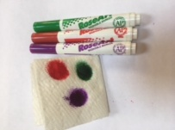
- apply pressure with your finger and

You can also make an ink pad with paint and a sponge.

Now you can make finger prints (it's a good idea to wash those hands now)
Then use the pens to make some details. Here are some ideas.

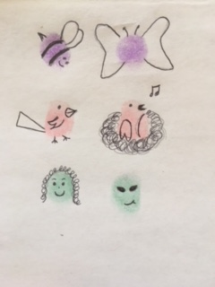

These are mine.
