
Hello Crafters! It’s another week and that means another craft. And this one will take some skill (or adult help )
Hooray!

Let’s make a
Twirling Butterflies

This is what you’ll need: 2 jumbo paper clips (or craft wire)
a pair of pliers
wire cutters (optional)
cardstock (or paper)
a small rubber band
scissors
pencil, markers, crayons – whatever you have

This is how to start:
- Use the pliers to unfold the paperclips as straight as you can
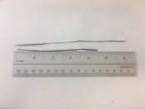
Cut one of them to 4.5” *tip: if you don’t have wire cutters just hold the pliers at 4.5” and bend the wire back and forth, it will break off easily.
(if you’re using wire, cut one piece at 6” and another at 4.5”)

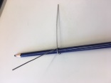
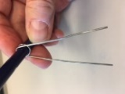
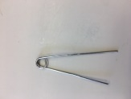
- Take the longer piece and place a pencil in the middle of it. Now bend one side over the pencil and then do the same with the other side. This is making a circle in the middle. Keep folding the wire all the way down.
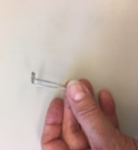
- Use the pliers to bend the circle so it is perpendicular to the “legs.”

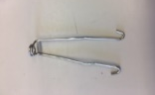
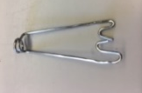
- Now bend the ends of the “legs” in an S formation. This is the butterfly’s body. Put it aside.

- Use the small wire and use the pencil again to start another circle in the middle, BUT, don’t wrap the wire all the way around. Just make a U shape. Pull the ends across each other making an X to close the circle.
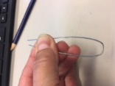
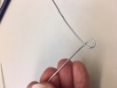

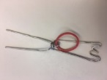
- Assemble the body of the butterfly. Wrap the rubber band around the top wire and set it in the center. Thread the rubber band through the loop of the bottom wire, and attach it onto the bottom hooks.
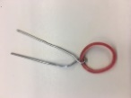
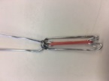

- Now the fun part! Make some wings. Get creative! They don’t have to be perfect!

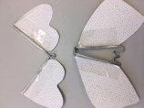
- Tape the bottom wings to the body.

- Tape the top wings to the top wires.

- Hold the bottom part and twist the top wings and twist and twist and twist and twist and twist . . . a lot . . .

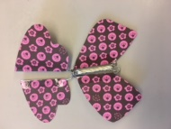
- Let go with both hands and your butterfly will fly away!
*you can twist this and then put it in a card. When your friend opens
the card the butterfly will fly out!

