Hello Everyone! This week’s craft will be especially fun for the drawers and colorers out there. So grab some paper, markers and your creativity!

Let’s make
Folded Surprise Pictures

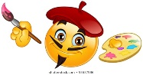
All you need is
    - paper
    - pencils, crayons, markers . . . whatever you like to color with

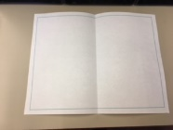
First, fold a piece of paper in half matching the short sides.
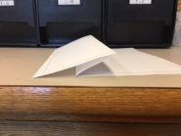
Then, fold the bottom half up so the center fold is about half of that.

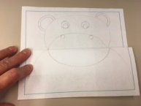
Now with the paper folded draw whatever you want in its closed position.
(The possibilities are endless! If you’d like, Google image “folded surprise pictures” for inspiration)
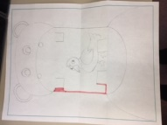

Then, unfold the paper and draw what is inside.
(Oops! I started coloring before taking the picture.)
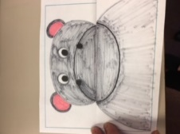
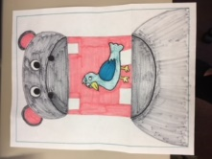
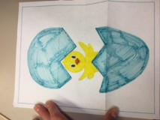
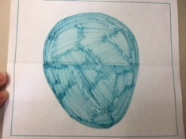
Last, color!

