This week I have something for you that you can use over and over again.
Let’s make…



This is what you’ll need:
small muffin tin (or little containers or an ice cube tray) baking soda
measuring cup with a spout (liquid measuring cup) white vinegar

cornstarch
food coloring
Recipe:
4 TBS baking soda 2 TBS cornstarch
2 TBS white vinegar food coloring (liquid or gel)
½ tsp light corn syrup

Instructions:
Mix the baking soda and vinegar together in a liquid measuring cup
Add the corn syrup and cornstarch
Mix well until it dissolves
Pour the mixture into the muffin tins (*The mixture will thicken if you stop stirring so keep it moving as you pour. Remember making goop? It would get hard until you squeezed it.)
Add 6 drops of liquid food color to each tin compartment. (Add a pinch of cornstarch. If you use a food coloring gel, you don’t have to.)
Let it sit for 24-48 hrs.
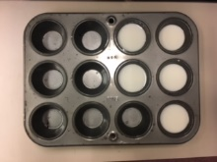
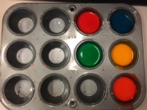
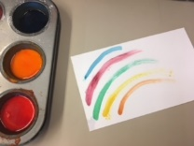
Use them just like a watercolor set. Just swish it with a wet paint brush.

