Now that the weather is getting warmer, let's make something to do outside!
This week I'm going to show you how to make...
Bubble Snakes

You will need: a plastic water bottle
an old sock
scissors
duck tape or a rubber band
dish detergent
a shallow pan
water
food coloring (optional)

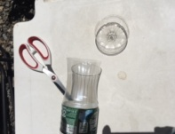
O.k.,

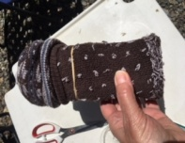
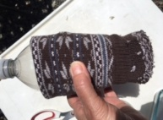
1. cut the bottom off of the water bottle

2. slide the sock over the bottom of the bottle and secure it with the tape/rubber band
(I folded the top of the sock down over the rubber band)
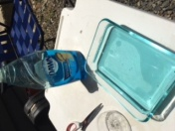
3. pour some water in a shallow container
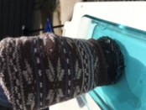
4. add some dish detergent

5. dip the sock end into the solution and

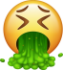
(DON'T SUCK IN! Dish soap tastes yucky!)

If you want to make colors, put some food coloring drops on the sock before you blow.

