This week we’re getting fancy! We’re going to make . . .
String Coasters
Things you will need: ruler
scissors
a copy of the flower template found below
string
decoupage glue (50/50 glue and water)
something flat that won’t stick to glue, like…
plastic binder divider, or
waxed paper

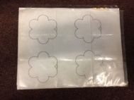
place the flower sheet under the plastic so you can see the picture
(you can also cut the flower out and trace it on the plastic)
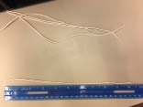
cut 6 strings about 10” long

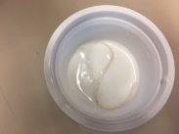
mix some glue and water in a bowl

soak each string in the glue

now place that string so it lines up with a pedal and spread the ends of the string anywhere within the flower
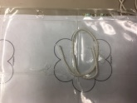
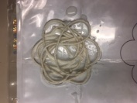
repeat this until the flower is covered

add some more glue all over

let it dry overnight

remove it from the plastic and pick off any glue from the edges and “holes”

Voila! They’re pretty, right?
